**Bike Ecommerce Store**

Software Design Document

**Team Members**

|  |  |
| --- | --- |
| **Name** | **ID** |
| **Akibur Rahman Akib** | **22-92573-2** |
| **Ummey Soaiba Yeasmin** | **21-92158-3** |
| **Md. Reaz Uddin Chowdhury** | **21-92155-3** |
| **Sheuly Akter** | **22-92609-2** |
| **Md. Rifat-Uz-Zaman** | **22-92610-2** |

|  |  |  |
| --- | --- | --- |
| **TABLE OF CONTENTS** | |  |
| **1.** | **I****NTRODUCTION** | **2** |
| 1.1 | Purpose | 2 |
| 1.2 | Scope | 2 |
| 1.3 | Overview | 2 |
| 1.4 | Reference Material | 2 |
| 1.5 | Definitions and Acronyms | 2 |
| **2.** | **S****YSTEM** **O****VERVIEW** | **2** |
| **3.** | **S****YSTEM** **A****RCHITECTURE** | **2** |
| 3.1 | Architectural Design | 2 |
| 3.2 | Decomposition Description | 3 |
| 3.3 | Design Rationale | 3 |
| **4.** | **D****ATA** **D****ESIGN** | **3** |
| 4.1 | Data Description | 3 |
| 4.2 | Data Dictionary | 3 |
| **5.** | **C****OMPONENT** **D****ESIGN** | **3** |
| **6.** | **H****UMAN** **I****NTERFACE** **D****ESIGN** | **4** |
| 6.1 | Overview of User Interface | 4 |
| 6.2 | Screen Images | 4 |

1. **INTRODUCTION**

**1.1 Purpose**

This document is intended for all the stakeholders of the system especially for the development team so that everyone is on the same page and clear visualization about the requirements of the system before development can start. SDD gives a clear visualization to the user end as well as developer end. The requirements should reduce ambiguity as much as possible for the project to be successful. The stakeholders include the product owner, the various users, the project manager, the software engineers and designers. By using this user can easily make understand the concept to the developer.

**1.2 Scope**

This software design document is intended for all the stakeholders but primarily for the development. team of the system so that everyone is on the same page and clear about the designs of the system before development can start. The design documents should reduce ambiguity as much as possible for the project to be successful. The stakeholders include the product owner, the various users, the project

manager, the software engineers and designers.

The E-commerce store will have two user classes

1. Customers
2. Admin

The customer will be able to browse through the different bikes, login/register and order a bike that he likes

The admin will be able to login, manage the different product information, view and manage the orders and create other admins accounts.  
  
The system will allow users to quickly and easily view the technical specifications of each bike and make a purchase in the comforts of their home. They don’t need to go to a show room to view and buy the bikes. This saves the customer time and the owner of the system to serve more customers without hiring more sales reps.

The Ecommerce platform will have an API and a react based frontend which will consume the API and provide functionality to the software.

**1.3 Overview**

This SDD document is divided primarily into 6 parts. First part Introduction provides an overall functional requirement of the system written in consultation with the owner of the system. This section provides a overview of the users, how the system will be used by the various stakeholders and any constraints of the system.

The other parts outlines the system architecture and data design. This section will primarily be used by the development team which includes designers, developers and testers to build the final version of the system. It also show the visualization of component design and human interface design. And finally ended with the requirement matrix.

**1.4 Reference Material**

1. https://reactjs.org/
2. <https://www.mongodb.com/>
3. <https://sendgrid.com/solutions/email-api/>  
   <https://www.sendinblue.com/api/>
4. <https://www.twilio.com/docs/sms/api>  
   <https://rapidapi.com/blog/sms-apis-send-texts/>.

**1.5 Definitions and Acronyms**

1. API- API stands for Application Programming Interface
2. React- A JavaScript library for building user interfaces
3. NodeJs A JavaScript library for building user interfaces
4. MongoDb – Schema less database
5. **SYSTEM OVERVIEW**

**Product Perspective:**

The software product is standalone cloud-based software which will be accessible via web

browsers. Dependencies include the SMS API used for OTP during registration and login and

email API used to send marketing and other confirmation emails.

**System Interfaces:**

The system must integrate with a third part SMS API to provide OTP and other SMS

notification to the users. Some of the options for an SMS API is given below

https://www.twilio.com/docs/sms/api

<https://rapidapi.com/blog/sms-apis-send-texts/>

The system should also integrate with an email API to send invoices and other email

notifications to the users. So third part Email APIs answer given below

https://sendgrid.com/solutions/email-api/

https://www.sendinblue.com/api/

**Interfaces:**

The software application will be a cloud-based platform where the customers will access a

frontend application using a web or mobile browser and the admin will also be able to

access the backend dashboard using a browser

**Hardware Interfaces:**

The users of the system can use any JavaScript enabled modern browser on a mobile or

desktop device to access the web based application. No other specific hardware interfaces are

required. A minimum of 1 GB RAM on the hardware device is recommended for smooth

performance.

**Software Interfaces:**

The customer currently does not have any software that needs to be interfaced with. So the

system will be standalone API and a frontend interface. We only have to interact with the

third-party email and SMS APIs to provide SMS and email functionality

**Communications Interfaces:**

Our web application will interface with the backend REST API using the standard TCP/IP

over the internet. A basic overview of TCP/IP is linked below

<https://www.fortinet.com/resources/cyberglossary/tcp-ip>

**Memory Constraints:**

To make sure the application is accessible to as many customers as possible the devices with

low end RAM and processor should be able to smoothly run the application using a browser

without any performance issues. Based on our focus groups the RAM requirements are 1 GB.

**Operations:**

The typical operations of the bike ecommerce include inventory management and keeping

track of the model and number of bikes currently in stock. When a new bike included in

stock the admin will add the bike from the backend portal so that the new bike is visible to

the users. When a customer orders a bike, the admin will view the order and will change the

status of the order accordingly. There will be no payment gateway in the ecommerce store so

all the orders will have cash on delivery by default.

**Site Adaptation Requirements:**

Admins should have a decent laptop with at least 4 GB RAM 3 GHz processor to operate the

backend portal of the system. The Admin laptops should also have continuous electricity and

a stable internet connection.

**Product Functions:**

**Customers**

1. Customers can Login
2. Customers can Register
3. Customers can Make orders
4. Customers can View their Orders
5. Customers can Cancel their order
6. Customers can Give reviews

**Admin**

1. Admin Can Login
2. Admin Can Register
3. Admin Can Manage Products
4. Admin Can Add Products
5. Admin Can make a user an admin
6. Admin Can manage Orders
7. Admin Can view profile

**User Characteristics:**

The primary users are customers who will access the system online. Users have minimal

technical knowledge about bikes and hence need intuitive navigation aids and simple page

layouts.

Administrator is responsible for maintaining the system and will be involved in software

fixes, deployment and regular maintenance.

**Admin Use Case**

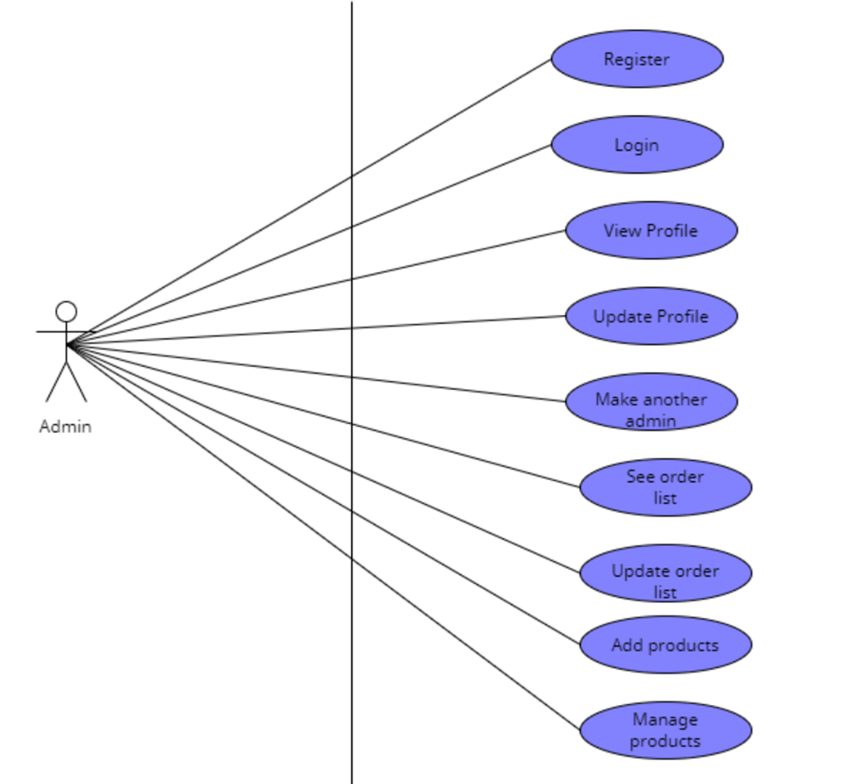

**Customer Use Case**

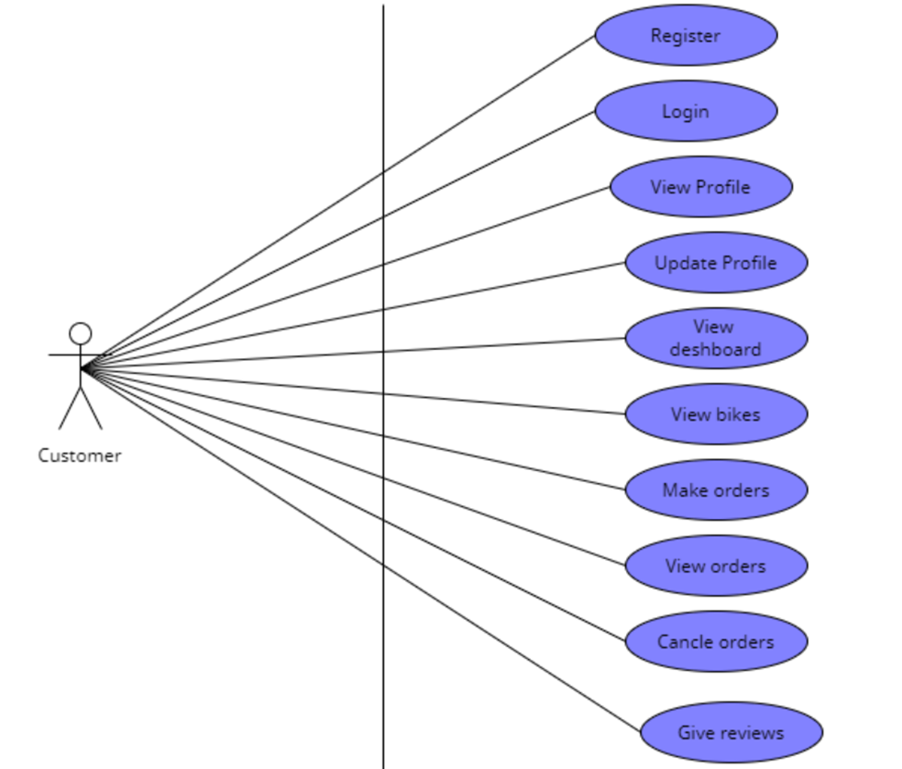

1. **SYSTEM ARCHITECTURE**

**3.1 Architectural Design**

The primary backbone of the web app is a nodejs based REST API which will be responsible to fetch and serve data to both the frontend app and the database server.

Two other third party APIs will be used to send SMS and email notifications

The front end will be a separate app built using a javascript library called React. React is a very flexible library that can generate static sites with dynamic data. This will allow the site to be very responsive and have very low load times which are necessary for a high converting ecommerce store

A class diagram is provide below to demonstrate how each component of the application will interact with each other



**3.2 Decomposition Description**

The customer will order a bike after viewing and signing into the platform. A flow diagram for the customer is provided below

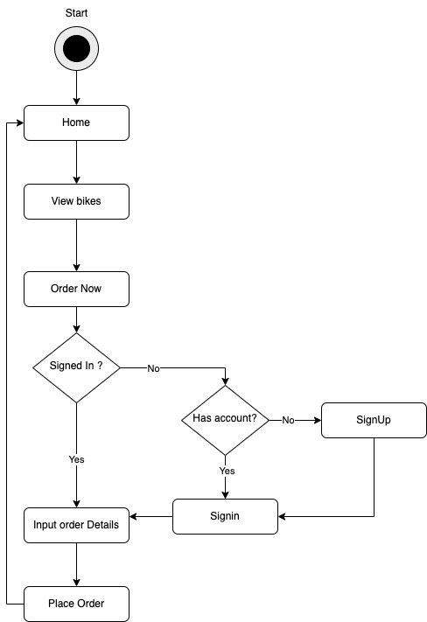

**3.3 Design Rationale**

REST API based architecture using NodeJs will allow very fast read/write operations. As it is well know node servers are not very good at cupute heavy tasks but are very good at fast read and write operations.

As an ecommerce store the web application will need to handle a lot of read and write requests but they wont be very copute heavy. So Node JS is used as the web server

React is used for the frontend for its

1. **DATA DESIGN**

**4.1 Data Description**

Though we are using MongoDB which is a schema less database we will still need a database structure which will map into an ORM so that it will be easier for the development to follow the database structure. The ER diagram of the system is given bellow



* 1. **Data Dictionary**

The data dictionary contains the datatype of each attribute based on the Entity Relation diagram and the keys that correspond to the relationship to it.

|  |  |  |  |
| --- | --- | --- | --- |
| **Entity** | **Attribute** | **Datatype** | **Key** |
| Customer | Id | Int(32) | Primary Key |
|  | Name | Varchar(256) |  |
|  | Phone | Varchar(256) |  |
|  | password | Varchar(256) |  |
|  | email | Varchar(256) |  |
| Admin | Id | Int(32) | Primary Key |
|  | Name | Varchar(256) |  |
|  | Email | Varchar(256) |  |
|  | Password | Varchar(256) |  |
|  | Phone | Varchar(256) |  |
| Product | Id | Int(32) | Primary Key |
|  | Name | Varchar(256) |  |
|  | Price | double |  |
|  | Description | Varchar(256) |  |
|  | ImageUrl | Varchar(256) |  |
| Order | Id | Int(32) | Primary Key |
|  | Status | Varchar(256) |  |
|  | Items | Array(100) |  |
|  | customerID | Int(32) | Foreign Key |

1. **HUMAN INTERFACE DESIGN**

**6.1 Overview of User Interface**

Describe the functionality of the system from the user’s perspective. Explain how the user will be able to use your system to complete all the expected features and the feedback information that will be displayed for the user.

**6.2 Screen Images**

# UI Wireframe

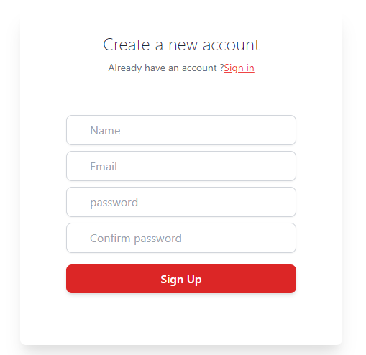

**Login interface**

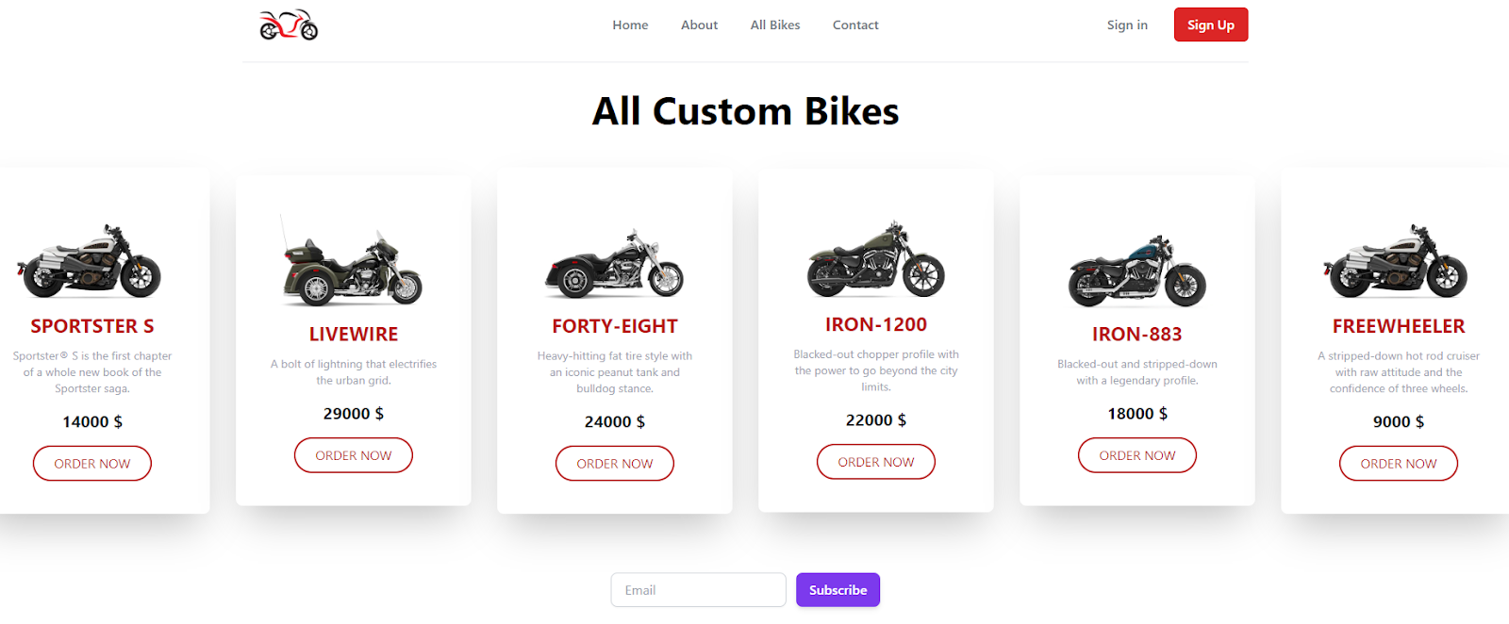

**View All Product**

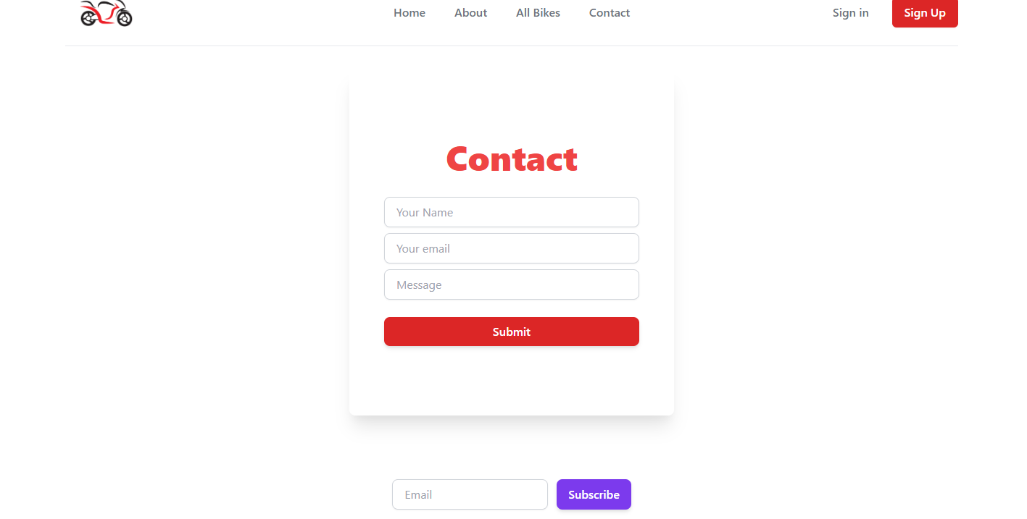

**Contact Page**

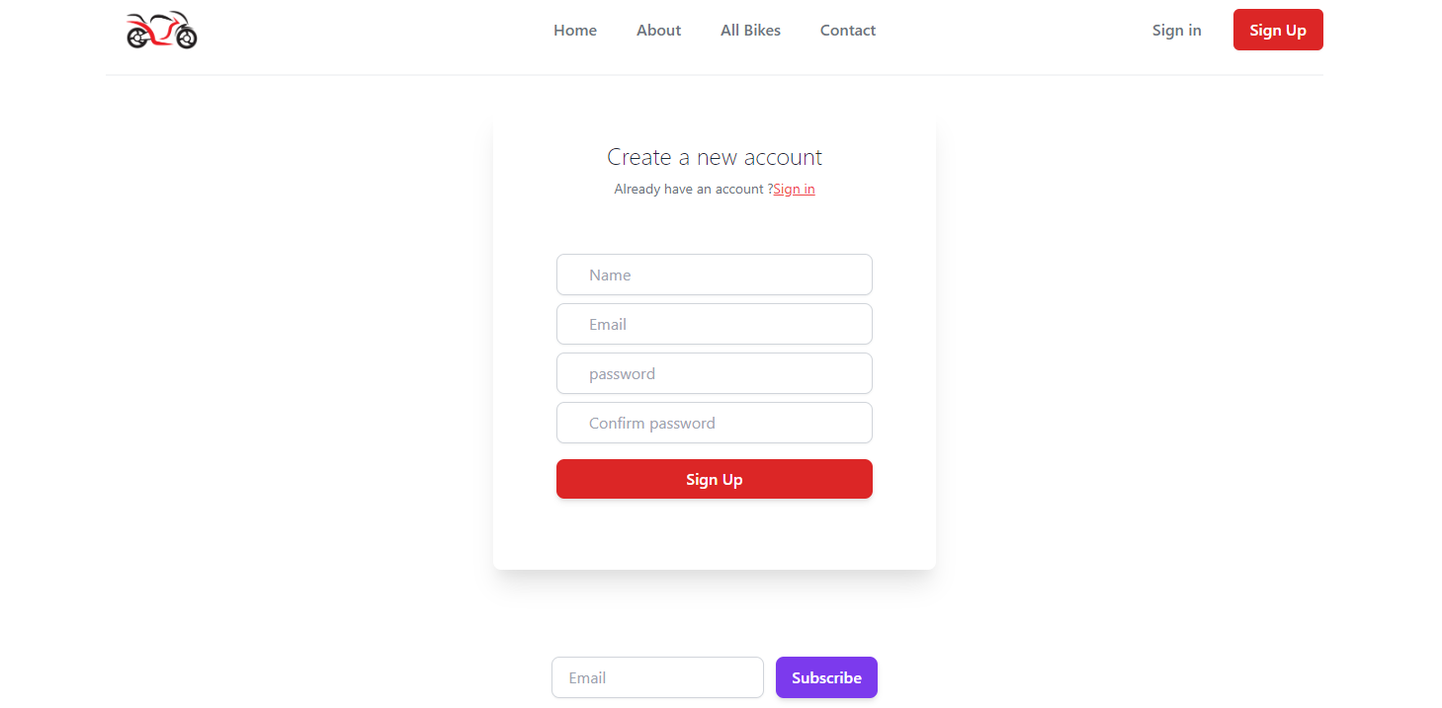

**Sign up page**

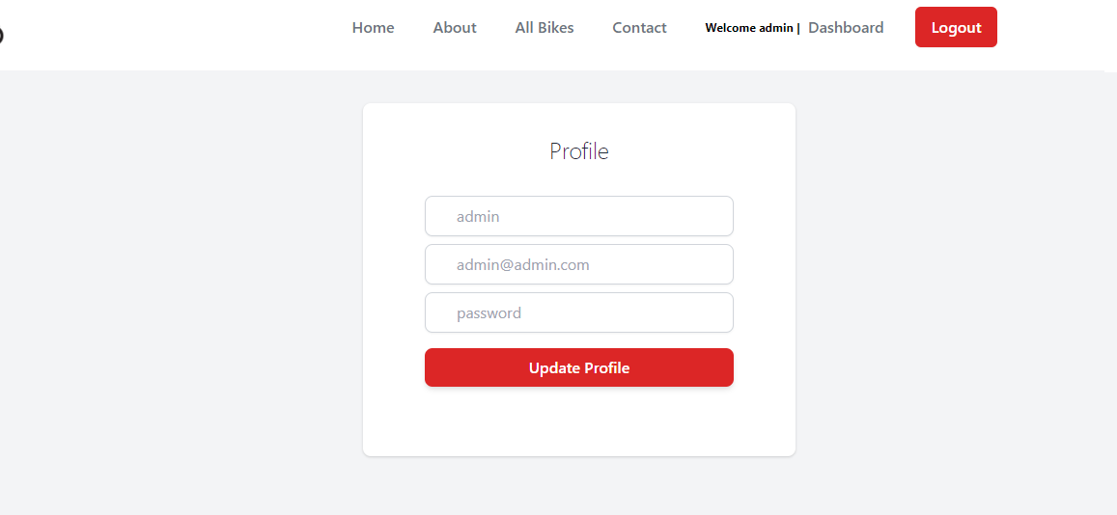

**update profile page**

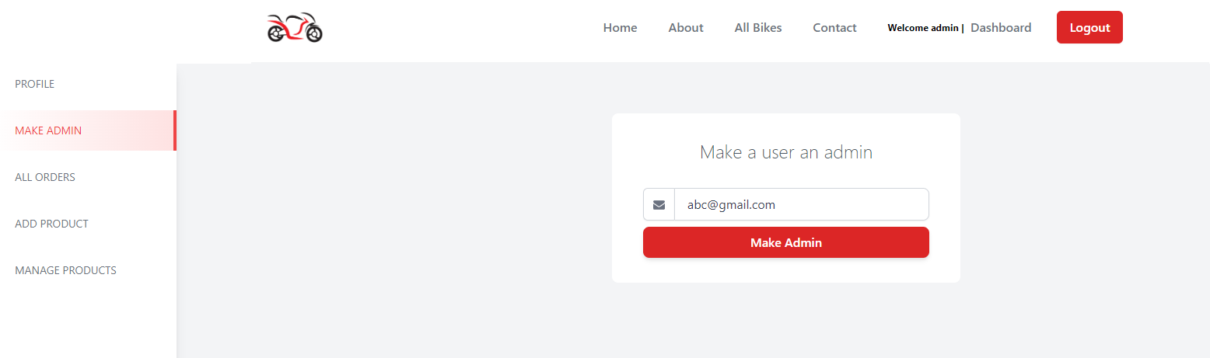

**Add user as admin**

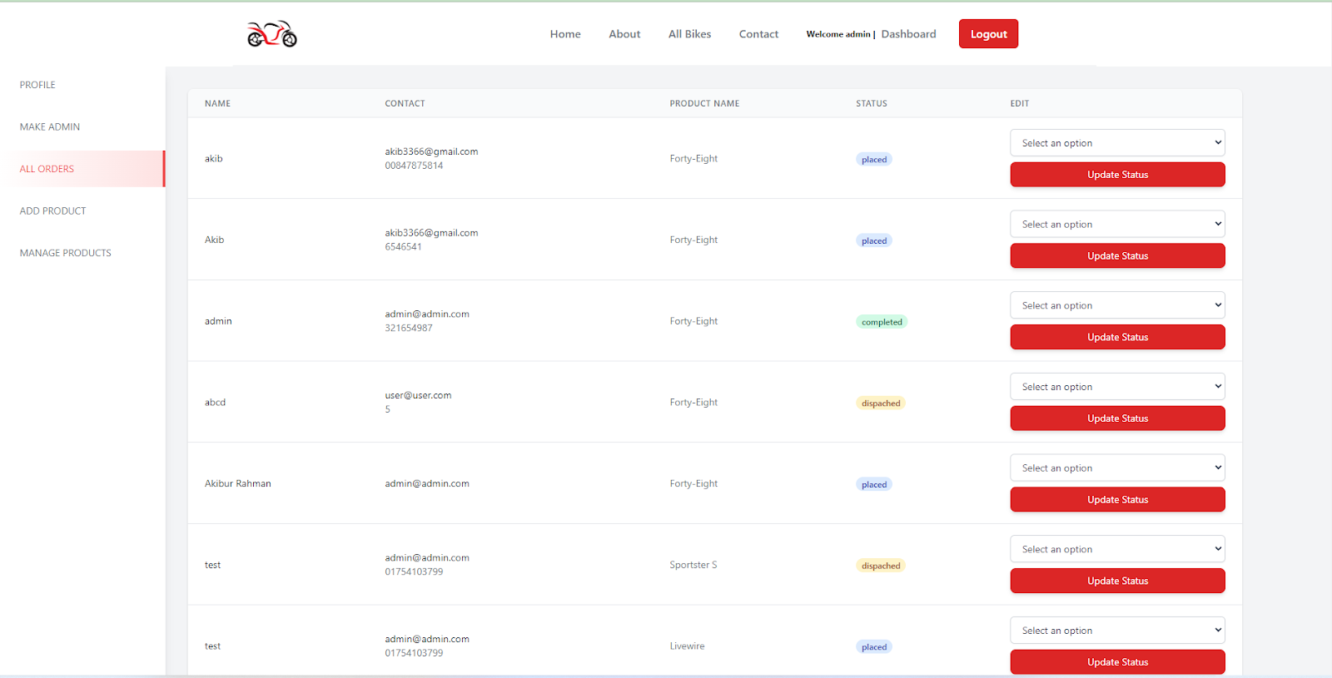

**Admin can manage order**

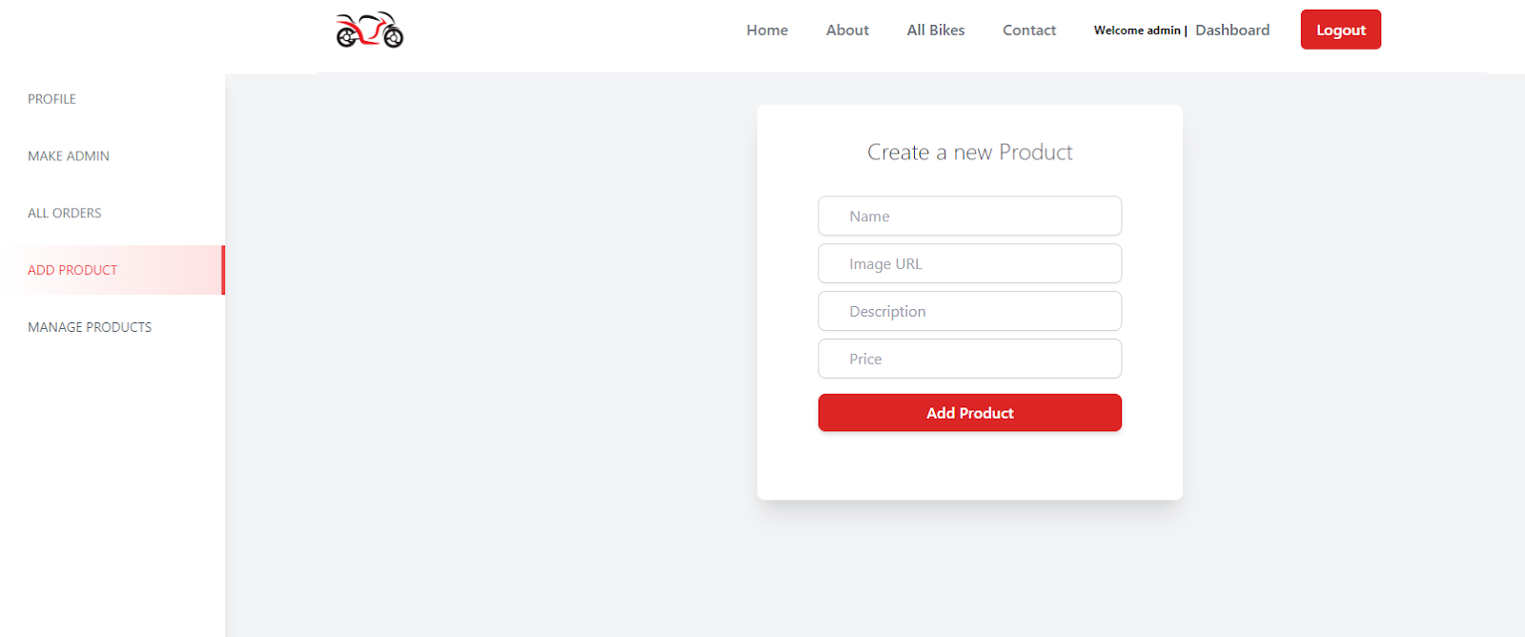

**Add product**

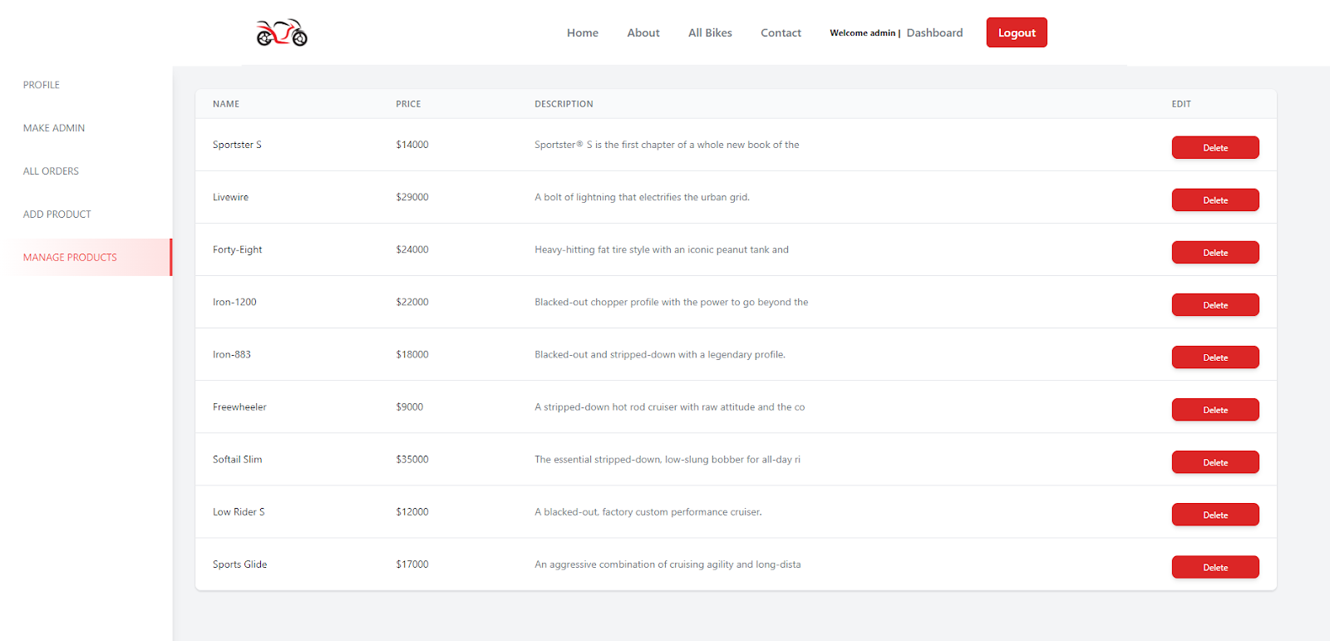

**Manage product**